What is Data Visualisation?

Why is data-visualisation important?

Usage matplotlib for data visualisation

## What is Matplotlib?

Matplotlib is a low level graph plotting library in python that serves as a import matplotlib.pyplot as plt

import numpy as np

xpoints = np.array([0, 6])

ypoints = np.array([0, 250])

plt.plot(xpoints, ypoints)

plt.show()visualization utility.

Matplotlib was created by John D. Hunter.

Matplotlib is open source and we can use it freely.

Matplotlib is mostly written in python, a few segments are written in C, Objective-C and Javascript for Platform compatibility.

## Installation of Matplotlib

If you have [Python](https://www.w3schools.com/python/default.asp) and [PIP](https://www.w3schools.com/python/python_pip.asp) already installed on a system, then installation of Matplotlib is very easy.

Install it using this command:

C:\Users*Your Name*>pip install matplotlib

## Import Matplotlib

Once Matplotlib is installed, import it in your applications by adding the import *module* statement:

import matplotlib

## Pyplot

Most of the Matplotlib utilities lies under the pyplot submodule, and are usually imported under the plt alias:

import matplotlib.pyplot as plt

Now the Pyplot package can be referred to as plt.

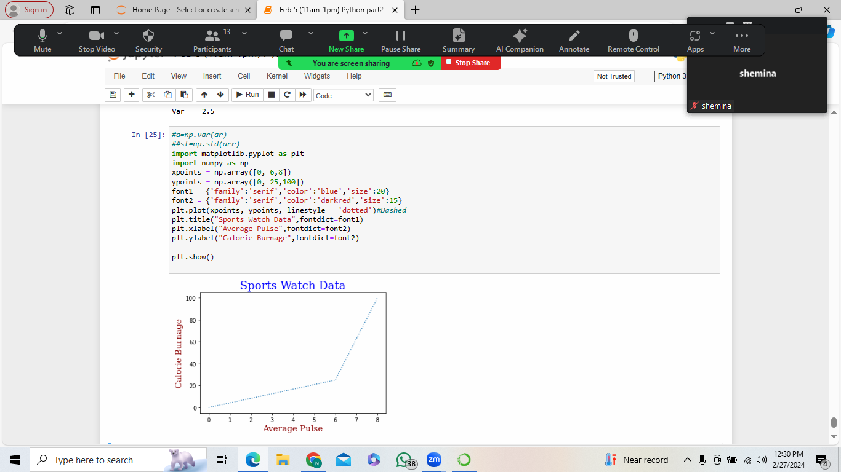

### Example

Draw a line in a diagram from position (0,0) to position (6,250):

### Result:

## Plotting x and y points

The plot() function is used to draw points (markers) in a diagram.

By default, the plot() function draws a line from point to point.

The function takes parameters for specifying points in the diagram.

Parameter 1 is an array containing the points on the x-axis.

Parameter 2 is an array containing the points on the y-axis.

If we need to plot a line from (1, 3) to (8, 10), we have to pass two arrays [1, 8] and [3, 10] to the plot function.

### Example

Draw a line in a diagram from position (1, 3) to position (8, 10):

import matplotlib.pyplot as plt

import numpy as np

xpoints = np.array([1, 8])

ypoints = np.array([3, 10])

plt.plot(xpoints, ypoints)

plt.show()

### Result:

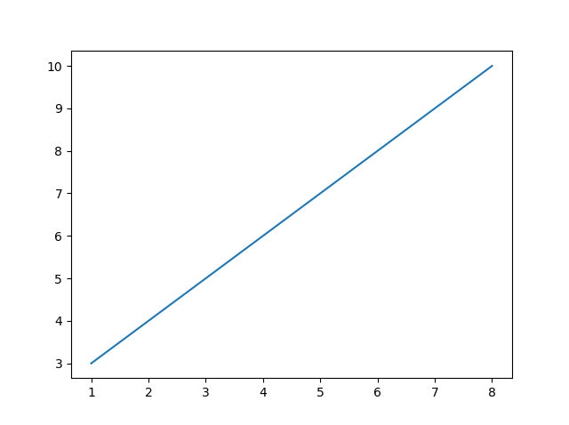

The x-axis is the horizontal axis.

The y-axis is the vertical axis.

## Plotting Without Line

To plot only the markers, you can use *shortcut string notation* parameter 'o', which means 'rings'.

### Example

Draw two points in the diagram, one at position (1, 3) and one in position (8, 10):

import matplotlib.pyplot as plt

import numpy as np

xpoints = np.array([1, 8])

ypoints = np.array([3, 10])

plt.plot(xpoints, ypoints, 'o')

## Multiple Points

You can plot as many points as you like, just make sure you have the same number of points in both axis.

### Example

Draw a line in a diagram from position (1, 3) to (2, 8) then to (6, 1) and finally to position (8, 10):

import matplotlib.pyplot as plt

import numpy as np

xpoints = np.array([1, 2, 6, 8])

ypoints = np.array([3, 8, 1, 10])

plt.plot(xpoints, ypoints)

plt.show()

### Result:

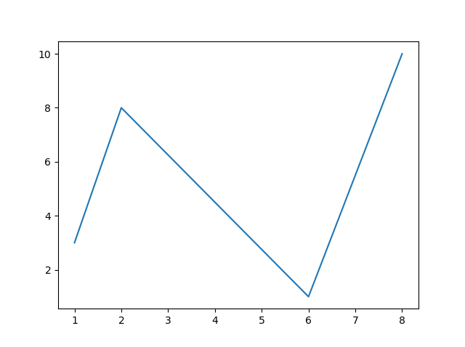

## Default X-Points

If we do not specify the points on the x-axis, they will get the default values 0, 1, 2, 3 (etc., depending on the length of the y-points.

So, if we take the same example as above, and leave out the x-points, the diagram will look like this:

### Example

Plotting without x-points:

import matplotlib.pyplot as plt

import numpy as np

ypoints = np.array([3, 8, 1, 10, 5, 7])

plt.plot(ypoints)

plt.show()

### Result:

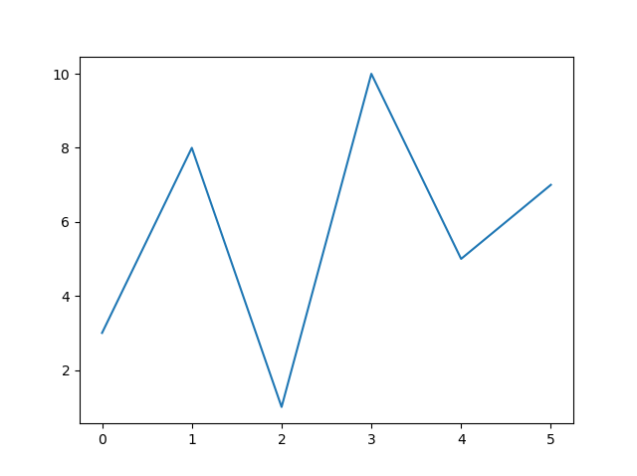

## Linestyle

You can use the keyword argument linestyle, or shorter ls, to change the style of the plotted line:

### Example

Use a dotted line:

import matplotlib.pyplot as plt

import numpy as np

ypoints = np.array([3, 8, 1, 10])

plt.plot(ypoints, linestyle = 'dotted')

plt.show()

### Result:

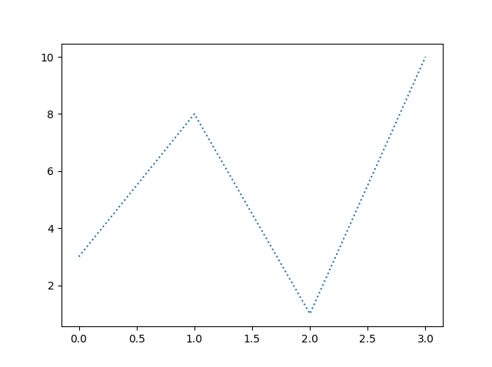

plt.plot(ypoints, linestyle = 'dashed')

### Result:

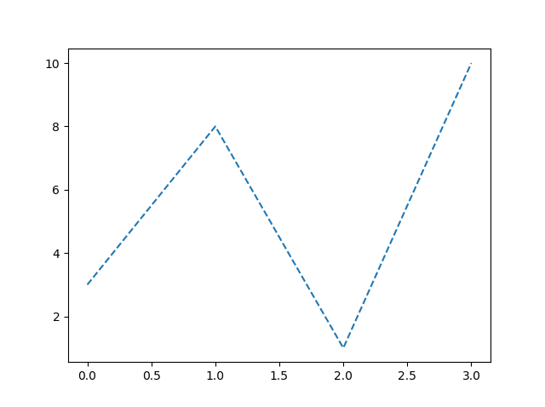

## Create Labels for a Plot

With Pyplot, you can use the xlabel() and ylabel() functions to set a label for the x- and y-axis.

### Example

Add labels to the x- and y-axis:

import numpy as np

import matplotlib.pyplot as plt

x = np.array([80, 85, 90, 95, 100, 105, 110, 115, 120, 125])

y = np.array([240, 250, 260, 270, 280, 290, 300, 310, 320, 330])

plt.plot(x, y)

plt.xlabel("Average Pulse")

plt.ylabel("Calorie Burnage")

plt.show()

### Result:

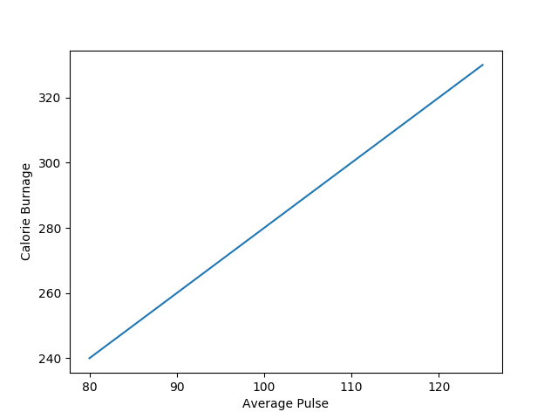

## Create a Title for a Plot

With Pyplot, you can use the title() function to set a title for the plot.

### Example

Add a plot title and labels for the x- and y-axis:

import numpy as np

import matplotlib.pyplot as plt

x = np.array([80, 85, 90, 95, 100, 105, 110, 115, 120, 125])

y = np.array([240, 250, 260, 270, 280, 290, 300, 310, 320, 330])

plt.plot(x, y)

plt.title("Sports Watch Data")

plt.xlabel("Average Pulse")

plt.ylabel("Calorie Burnage")

plt.show()

### Result:

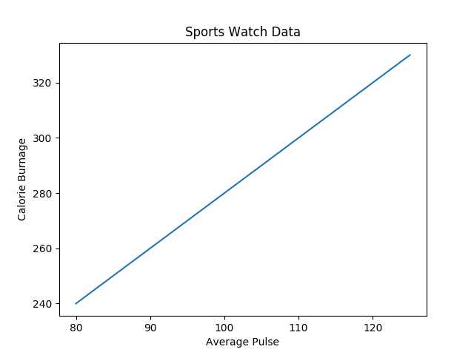

## Set Font Properties for Title and Labels

You can use the fontdict parameter in xlabel(), ylabel(), and title() to set font properties for the title and labels.

### Example

Set font properties for the title and labels:

import numpy as np

import matplotlib.pyplot as plt

x = np.array([80, 85, 90, 95, 100, 105, 110, 115, 120, 125])

y = np.array([240, 250, 260, 270, 280, 290, 300, 310, 320, 330])

font1 = {'family':'serif','color':'blue','size':20}

font2 = {'family':'serif','color':'darkred','size':15}

plt.title("Sports Watch Data", fontdict = font1)

plt.xlabel("Average Pulse", fontdict = font2)

plt.ylabel("Calorie Burnage", fontdict = font2)

plt.plot(x, y)

plt.show()

### Result:

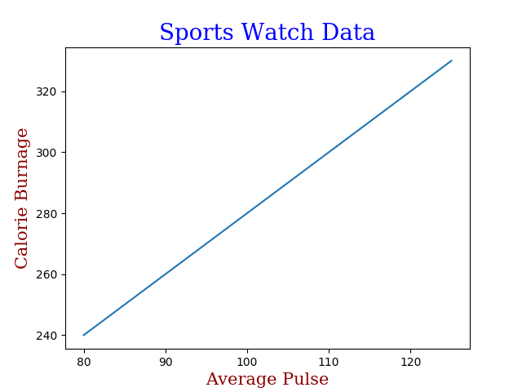

## Add Grid Lines to a Plot

With Pyplot, you can use the grid() function to add grid lines to the plot.

### Example

Add grid lines to the plot:

import numpy as np

import matplotlib.pyplot as plt

x = np.array([80, 85, 90, 95, 100, 105, 110, 115, 120, 125])

y = np.array([240, 250, 260, 270, 280, 290, 300, 310, 320, 330])

plt.title("Sports Watch Data")

plt.xlabel("Average Pulse")

plt.ylabel("Calorie Burnage")

plt.plot(x, y)

plt.grid()

plt.show()

### Result:

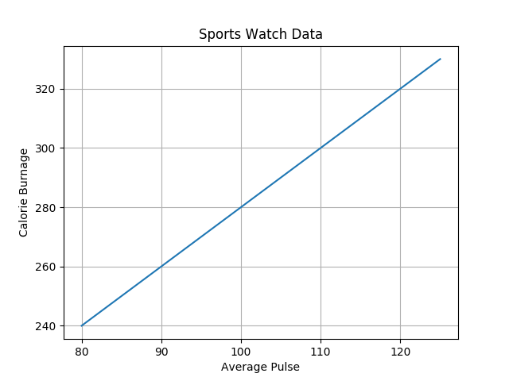

## Specify Which Grid Lines to Display

You can use the axis parameter in the grid() function to specify which grid lines to display.

Legal values are: 'x', 'y', and 'both'. Default value is 'both'.

### Example

Display only grid lines for the x-axis:

import numpy as np

import matplotlib.pyplot as plt

x = np.array([80, 85, 90, 95, 100, 105, 110, 115, 120, 125])

y = np.array([240, 250, 260, 270, 280, 290, 300, 310, 320, 330])

plt.title("Sports Watch Data")

plt.xlabel("Average Pulse")

plt.ylabel("Calorie Burnage")

plt.plot(x, y)

plt.grid(axis = 'x')

plt.show()

### Result:

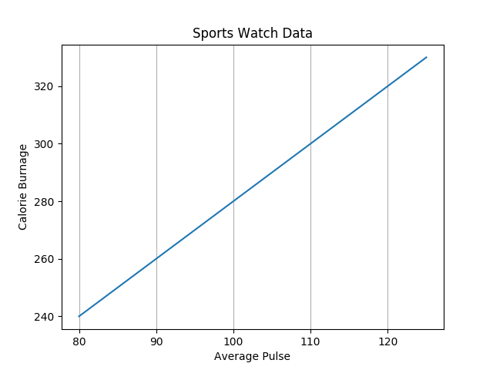

## Creating Scatter Plots

With Pyplot, you can use the scatter() function to draw a scatter plot.

The scatter() function plots one dot for each observation. It needs two arrays of the same length, one for the values of the x-axis, and one for values on the y-axis:

### Example

A simple scatter plot:

import matplotlib.pyplot as plt

import numpy as np

x = np.array([5,7,8,7,2,17,2,9,4,11,12,9,6])

y = np.array([99,86,87,88,111,86,103,87,94,78,77,85,86])

plt.scatter(x, y)

plt.show()

Or

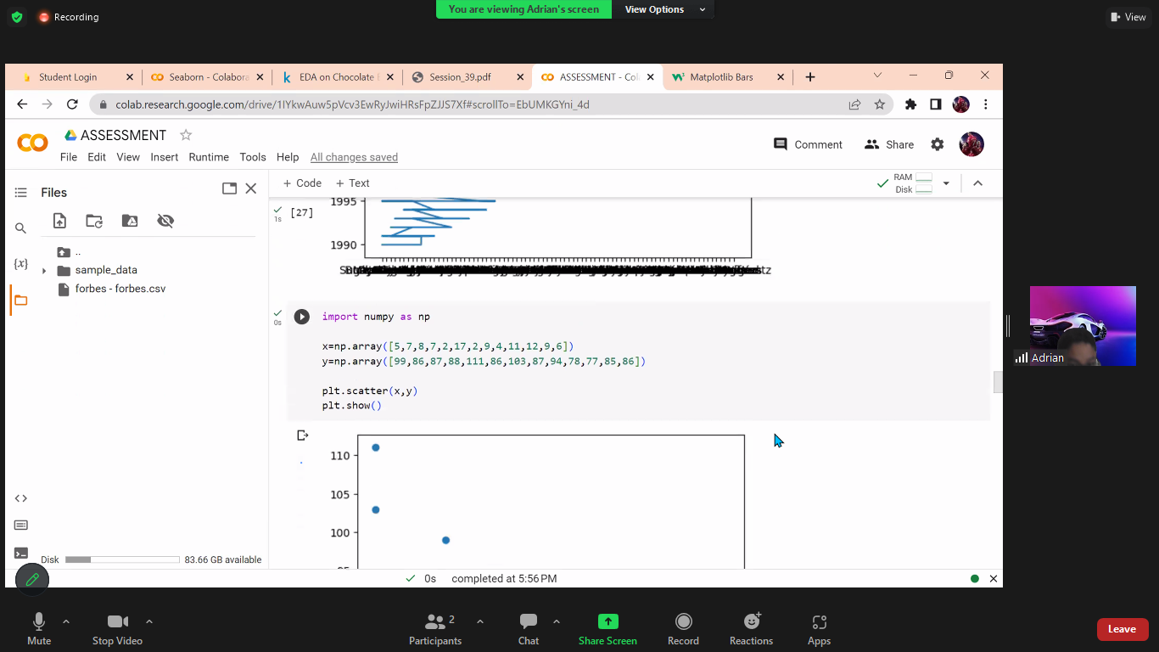

### Result:

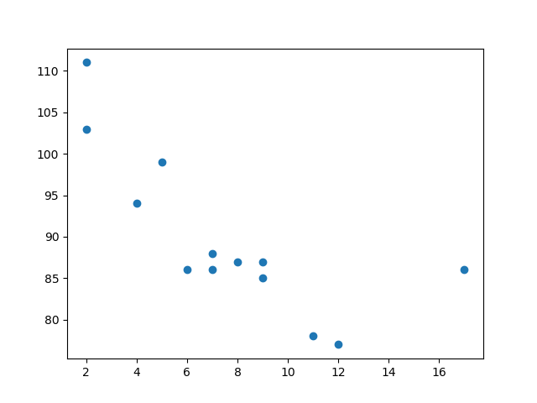

The observation in the example above is the result of 13 cars passing by.

The X-axis shows how old the car is.

The Y-axis shows the speed of the car when it passes.

Are there any relationships between the observations?

It seems that the newer the car, the faster it drives, but that could be a coincidence, after all we only registered 13 cars.

## Compare Plots

In the example above, there seems to be a relationship between speed and age, but what if we plot the observations from another day as well? Will the scatter plot tell us something else?

### Example

Draw two plots on the same figure:

import matplotlib.pyplot as plt

import numpy as np

#day one, the age and speed of 13 cars:

x = np.array([5,7,8,7,2,17,2,9,4,11,12,9,6])

y = np.array([99,86,87,88,111,86,103,87,94,78,77,85,86])

plt.scatter(x, y)

#day two, the age and speed of 15 cars:

x = np.array([2,2,8,1,15,8,12,9,7,3,11,4,7,14,12])

y = np.array([100,105,84,105,90,99,90,95,94,100,79,112,91,80,85])

plt.scatter(x, y)

plt.show()

### Result:

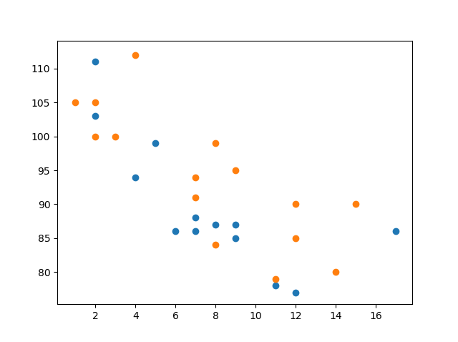

## Creating Bars

With Pyplot, you can use the bar() function to draw bar graphs:

### Example

Draw 4 bars:

import matplotlib.pyplot as plt

import numpy as np

x = np.array(["A", "B", "C", "D"])

y = np.array([3, 8, 1, 10])

plt.bar(x,y)

plt.show()

Or

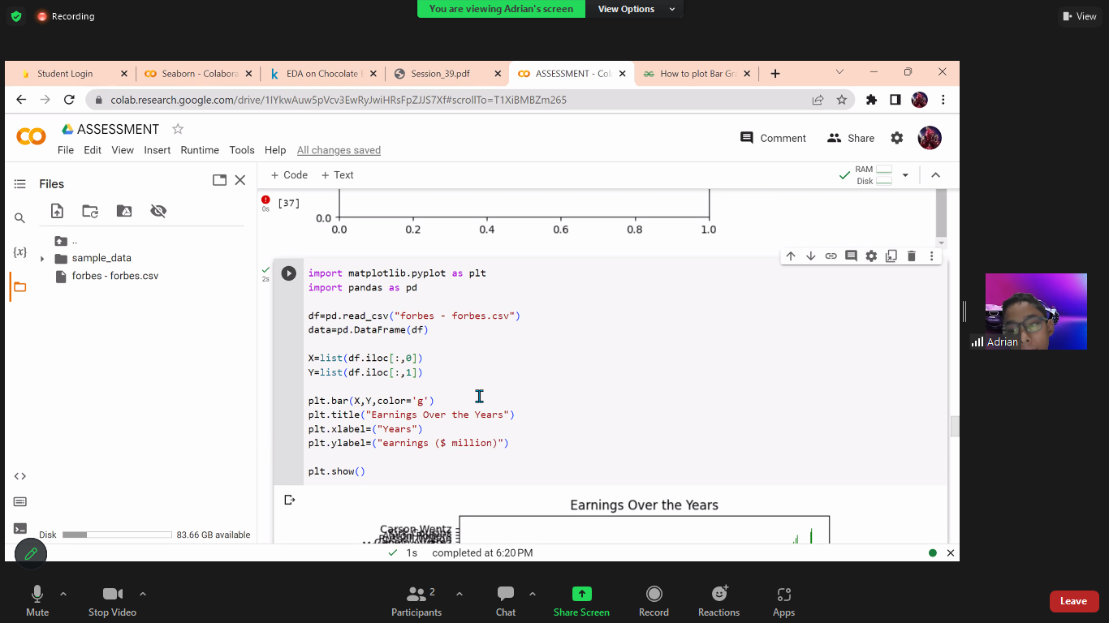

### Result:

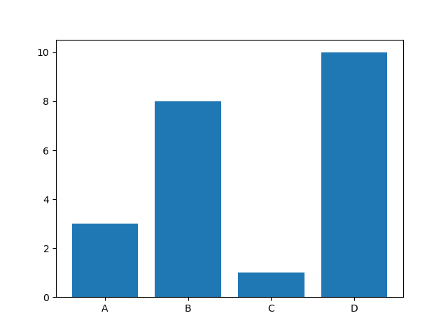

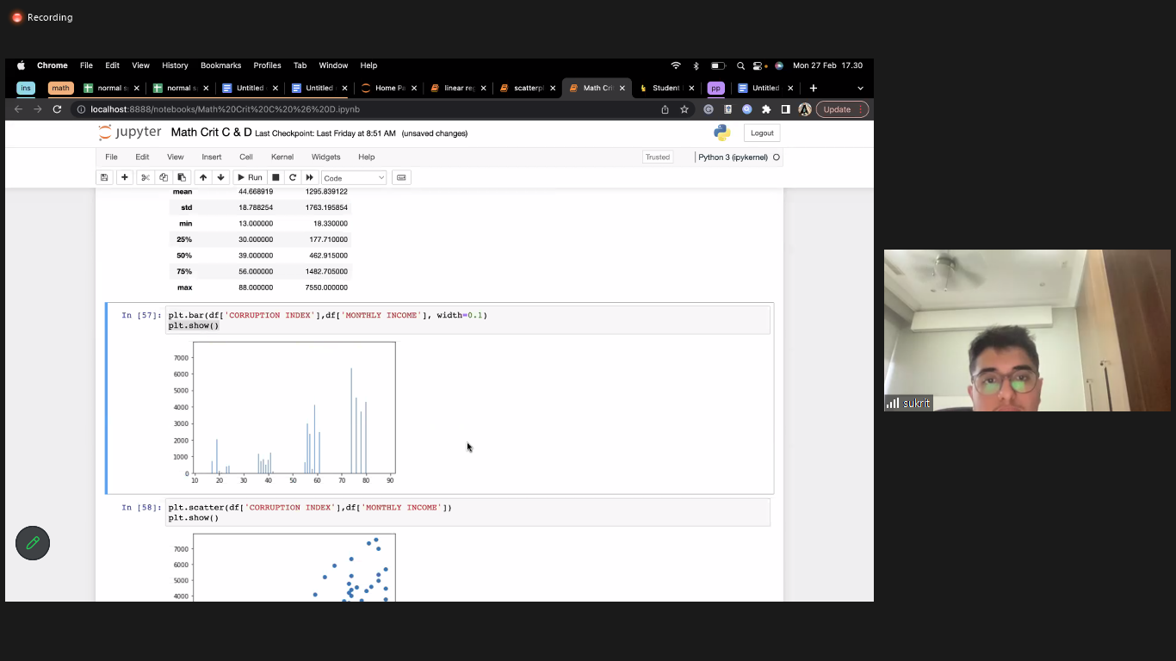

## Horizontal Bars

If you want the bars to be displayed horizontally instead of vertically, use the barh() function:

### Example

Draw 4 horizontal bars:

import matplotlib.pyplot as plt

import numpy as np

x = np.array(["A", "B", "C", "D"])

y = np.array([3, 8, 1, 10])

plt.barh(x, y)

plt.show()

### Result:

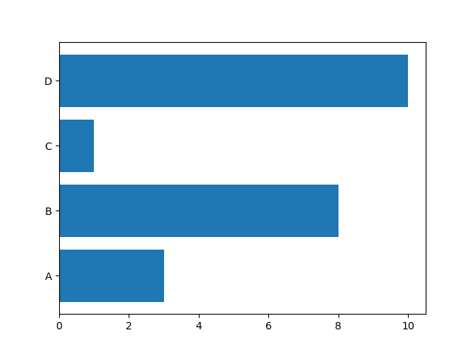

## Bar Color

The bar() and barh() take the keyword argument color to set the color of the bars:

### Example

Draw 4 red bars:

import matplotlib.pyplot as plt

import numpy as np

x = np.array(["A", "B", "C", "D"])

y = np.array([3, 8, 1, 10])

plt.bar(x, y, color = "red")

plt.show()

### Result:

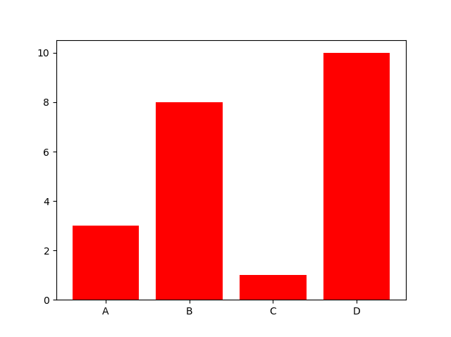

## Bar Width

The bar() takes the keyword argument width to set the width of the bars:

### Example

Draw 4 very thin bars:

import matplotlib.pyplot as plt

import numpy as np

x = np.array(["A", "B", "C", "D"])

y = np.array([3, 8, 1, 10])

plt.bar(x, y, width = 0.1)

plt.show()

### Result:

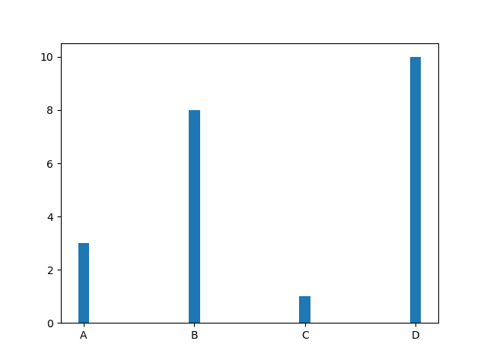

## Histogram

A histogram is a graph showing *frequency* distributions.

It is a graph showing the number of observations within each given interval.

Example: Say you ask for the height of 250 people, you might end up with a histogram like this:

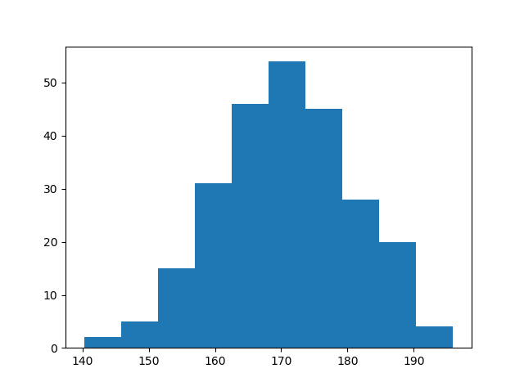

You can read from the histogram that there are approximately:

2 people from 140 to 145cm

5 people from 145 to 150cm

15 people from 151 to 156cm

31 people from 157 to 162cm

46 people from 163 to 168cm

53 people from 168 to 173cm

45 people from 173 to 178cm

28 people from 179 to 184cm

21 people from 185 to 190cm

4 people from 190 to 195cm

## Create Histogram

In Matplotlib, we use the hist() function to create histograms.

The hist() function will use an array of numbers to create a histogram, the array is sent into the function as an argument.

For simplicity we use NumPy to randomly generate an array with 250 values, where the values will concentrate around 170, and the standard deviation is 10.

### Example

A Normal Data Distribution by NumPy:

import numpy as np

x = np.random.normal(170, 10, 250)

print(x)

### Result:

This will generate a *random* result, and could look like this:

[167.62255766 175.32495609 152.84661337 165.50264047 163.17457988

162.29867872 172.83638413 168.67303667 164.57361342 180.81120541

170.57782187 167.53075749 176.15356275 176.95378312 158.4125473

187.8842668 159.03730075 166.69284332 160.73882029 152.22378865

164.01255164 163.95288674 176.58146832 173.19849526 169.40206527

166.88861903 149.90348576 148.39039643 177.90349066 166.72462233

177.44776004 170.93335636 173.26312881 174.76534435 162.28791953

166.77301551 160.53785202 170.67972019 159.11594186 165.36992993

178.38979253 171.52158489 173.32636678 159.63894401 151.95735707

175.71274153 165.00458544 164.80607211 177.50988211 149.28106703

179.43586267 181.98365273 170.98196794 179.1093176 176.91855744

168.32092784 162.33939782 165.18364866 160.52300507 174.14316386

163.01947601 172.01767945 173.33491959 169.75842718 198.04834503

192.82490521 164.54557943 206.36247244 165.47748898 195.26377975

164.37569092 156.15175531 162.15564208 179.34100362 167.22138242

147.23667125 162.86940215 167.84986671 172.99302505 166.77279814

196.6137667 159.79012341 166.5840824 170.68645637 165.62204521

174.5559345 165.0079216 187.92545129 166.86186393 179.78383824

161.0973573 167.44890343 157.38075812 151.35412246 171.3107829

162.57149341 182.49985133 163.24700057 168.72639903 169.05309467

167.19232875 161.06405208 176.87667712 165.48750185 179.68799986

158.7913483 170.22465411 182.66432721 173.5675715 176.85646836

157.31299754 174.88959677 183.78323508 174.36814558 182.55474697

180.03359793 180.53094948 161.09560099 172.29179934 161.22665588

171.88382477 159.04626132 169.43886536 163.75793589 157.73710983

174.68921523 176.19843414 167.39315397 181.17128255 174.2674597

186.05053154 177.06516302 171.78523683 166.14875436 163.31607668

174.01429569 194.98819875 169.75129209 164.25748789 180.25773528

170.44784934 157.81966006 171.33315907 174.71390637 160.55423274

163.92896899 177.29159542 168.30674234 165.42853878 176.46256226

162.61719142 166.60810831 165.83648812 184.83238352 188.99833856

161.3054697 175.30396693 175.28109026 171.54765201 162.08762813

164.53011089 189.86213299 170.83784593 163.25869004 198.68079225

166.95154328 152.03381334 152.25444225 149.75522816 161.79200594

162.13535052 183.37298831 165.40405341 155.59224806 172.68678385

179.35359654 174.19668349 163.46176882 168.26621173 162.97527574

192.80170974 151.29673582 178.65251432 163.17266558 165.11172588

183.11107905 169.69556831 166.35149789 178.74419135 166.28562032

169.96465166 178.24368042 175.3035525 170.16496554 158.80682882

187.10006553 178.90542991 171.65790645 183.19289193 168.17446717

155.84544031 177.96091745 186.28887898 187.89867406 163.26716924

169.71242393 152.9410412 158.68101969 171.12655559 178.1482624

187.45272185 173.02872935 163.8047623 169.95676819 179.36887054

157.01955088 185.58143864 170.19037101 157.221245 168.90639755

178.7045601 168.64074373 172.37416382 165.61890535 163.40873027

168.98683006 149.48186389 172.20815568 172.82947206 173.71584064

189.42642762 172.79575803 177.00005573 169.24498561 171.55576698

161.36400372 176.47928342 163.02642822 165.09656415 186.70951892

153.27990317 165.59289527 180.34566865 189.19506385 183.10723435

173.48070474 170.28701875 157.24642079 157.9096498 176.4248199 ]

The hist() function will read the array and produce a histogram:

### Example

A simple histogram:

import matplotlib.pyplot as plt

import numpy as np

import random

x = np.random.normal(170, 10, 250)#(mean,difference b/w 2 points(std),250 observations)

plt.hist(x)

plt.show()

### Result:



## Creating Pie Charts

With Pyplot, you can use the pie() function to draw pie charts:

### Example

A simple pie chart:

import matplotlib.pyplot as plt

import numpy as np

y = np.array([35, 25, 25, 15])

plt.pie(y)

plt.show()

### Result:

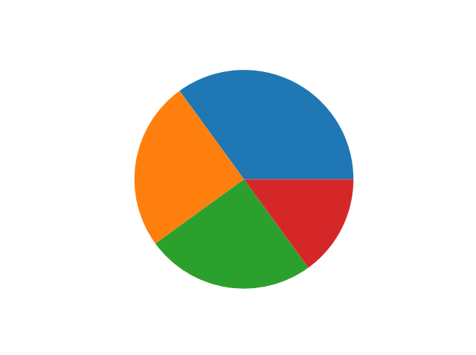

## Labels

Add labels to the pie chart with the label parameter.

The label parameter must be an array with one label for each wedge:

### Example

A simple pie chart:

import matplotlib.pyplot as plt

import numpy as np

y = np.array([35, 25, 25, 15])

mylabels = ["Apples", "Bananas", "Cherries", "Dates"]

plt.pie(y, labels = mylabels)

plt.show()

### Result:

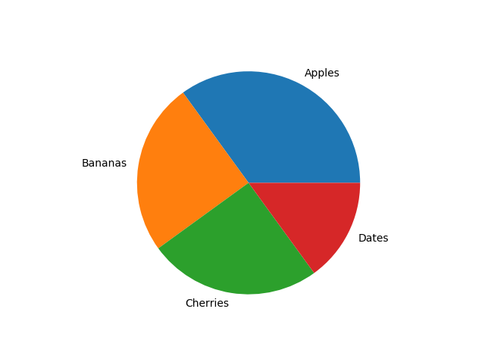

## Explode

Maybe you want one of the wedges to stand out? The explode parameter allows you to do that.

The explode parameter, if specified, and not None, must be an array with one value for each wedge.

Each value represents how far from the center each wedge is displayed:

### Example

Pull the "Apples" wedge 0.2 from the center of the pie:

import matplotlib.pyplot as plt

import numpy as np

y = np.array([35, 25, 25, 15])

mylabels = ["Apples", "Bananas", "Cherries", "Dates"]

myexplode = [0.2, 0, 0, 0]

plt.pie(y, labels = mylabels, explode = myexplode)

plt.show()

### Result:

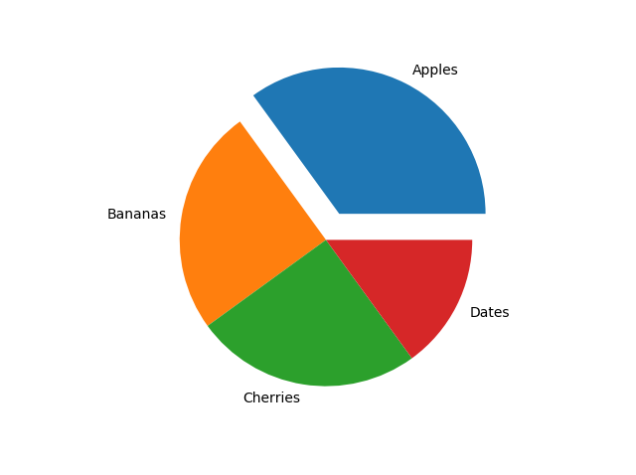

### Legend With Header

To add a header to the legend, add the title parameter to the legend function.

### Example

Add a legend with a header:

import matplotlib.pyplot as plt

import numpy as np

y = np.array([35, 25, 25, 15])

mylabels = ["Apples", "Bananas", "Cherries", "Dates"]

plt.pie(y, labels = mylabels)

plt.legend(title = "Four Fruits:")

plt.show()

### Result:

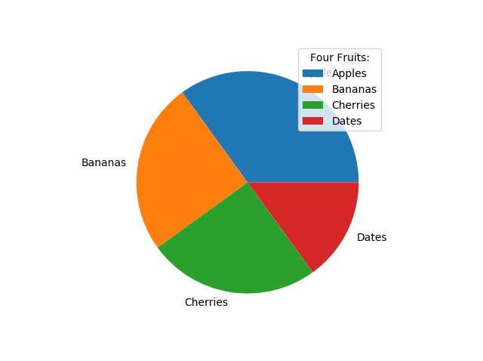

size = np.array([35, 25, 25, 15])

labels = ["Apples", "Bananas", "Cherries", "Dates"]

[fig](https://matplotlib.org/stable/api/figure_api.html#matplotlib.figure.Figure)**,** [ax](https://matplotlib.org/stable/api/_as_gen/matplotlib.axes.Axes.html#matplotlib.axes.Axes) **=** [plt**.**subplots](https://matplotlib.org/stable/api/_as_gen/matplotlib.pyplot.subplots.html#matplotlib.pyplot.subplots)**()**

[ax**.**pie](https://matplotlib.org/stable/api/_as_gen/matplotlib.axes.Axes.pie.html#matplotlib.axes.Axes.pie)**(**[size](https://docs.python.org/3/library/stdtypes.html#list)**,** [labels](https://docs.python.org/3/library/stdtypes.html#tuple)**=**[labels](https://docs.python.org/3/library/stdtypes.html#tuple)**,** autopct**=**'%1.1f%%'**)**

**Or**

**y=np.array([35,25,25,15])**

**mylabel=["Apple","Banana","Cherry","kiwi"]**

**plt.pie(y,labels=mylabel,autopct="%1.1f%%")**

**plt.show()**

By default, the label values are obtained from the percent size of the slice.

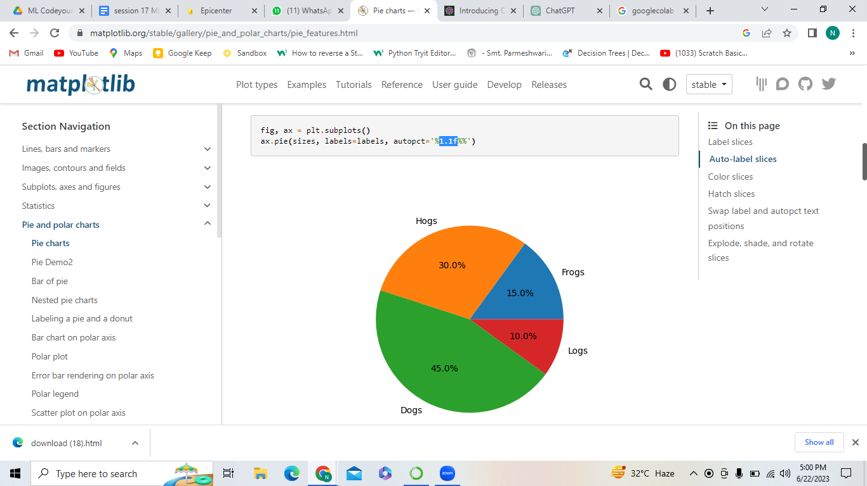

The line ax.pie(sizes, labels=labels, autopct='%1.1f%%') is a Python code snippet that uses the Matplotlib library to create a pie chart.

Let's break down the components of this line:

* ax: It is an instance of the Axes class in Matplotlib, representing a single plot within a figure. ax is usually obtained by calling plt.subplots() or plt.subplot() to create a figure and axes.
* pie(): It is a method provided by the Axes class in Matplotlib that creates a pie chart. It takes several parameters to customize the appearance and content of the chart.
* sizes: It is a list or array-like object containing the sizes or proportions of each pie slice. The sizes determine the area of each slice in the pie chart.
* labels: It is an optional parameter that specifies the labels for each slice in the pie chart. It can be a list or array-like object containing the labels corresponding to the sizes.
* autopct: It is an optional parameter that controls the display format of the autopct (automatic percent) labels on the pie chart. In this case, '%1.1f%%' is used as the format string. It formats the autopct labels to display the percentage value with one digit after the decimal point followed by the '%' symbol.
* Putting it all together, the line of code ax.pie(sizes, labels=labels, autopct='%1.1f%%') creates a pie chart on the ax subplot using the specified sizes and labels. It also displays the percentage values for each slice with one decimal place.

Seaborn all the functions:<https://www.geeksforgeeks.org/barplot-using-seaborn-in-python/?ref=lbp>